

**D-CorpLedger**

**Design & developed by**

K. NEERAJ (2211CS040079)

**GUIDED BY**

**Dr. M.V.N. Srujan Manohar**

Associate Professor

**Department of Computer Science & Engineering (Cyber Security)**

**III YR – I SEM**

**Malla Reddy University, Hyderabad**

**2022-2026**



**Department of CSE – CYBER SECURITY**

**CERTIFICATE**

This is to certify that this is the bonafide record of the application development entitled **“D-CorpLedger”,** submittedby **K. NEERAJ (2211CS040079)** of B.Tech III year I semester, Department of CSE (CS) during the year 2024-25. The results embodied in this report have not been submitted to any other University or institute for the award of any degree or diploma.

**Internal Guide Head of the Department**

**Dr. M.V.N. Srujan Manohar Dr. G. Anand Kumar**

**(Associate Professor) CSE(Cyber Security)**

## External Examiner

**ACKNOWLEDGEMENT**

I extend my sincere gratitude to all those who have contributed to the completion of this project report. Firstly, I would like to extend my gratitude to **Dr. V. S. K Reddy**, Vice-Chancellor, for his visionary leadership and unwavering commitment to academic excellence.

I would also like to express my deepest appreciation to my project guide, **Dr. M.V.N. Srujan Manohar**, Associate Professor, whose invaluable guidance, insightful feedback, and unwavering support have been instrumental throughout the course of this project, enabling its successful outcomes.

I extend my gratitude to **Dr. G. Latha**, PRC-convenor, for providing valuable inputs and timely guidelines, which greatly improved the quality of my project through a critical review process. I also thank my project coordinator, Mr. Ravi Kumar Muthyala, for his timely support.

I am grateful to **Dr. G. Anand Kumar**, Head of the Department of Cybersecurity, for providing the necessary resources and facilities to carry out this project.

I would like to thank **Dr. Harikrishna Kamatham**, Dean, School of Engineering, for his encouragement and support throughout my academic pursuits.

I am deeply indebted to all of them for their support, encouragement, and guidance, without which this project would not have been possible.

K. NEERAJ (2211CS040079)

## 

## ABSTRACT

## D-CorpLedger represents a paradigm shift in corporate governance, harnessing blockchain technology to revolutionize shareholder voting with unprecedented levels of security, transparency, and efficiency. By leveraging the immutable properties of blockchain, D-CorpLedger removes the need for traditional intermediaries, ensuring that each vote is permanently and verifiably recorded. This decentralized ledger system not only strengthens the voting process against tampering and fraud but also upholds the integrity of corporate decision-making, providing a foundation for greater trust among stakeholders.

## The decentralized architecture of D-CorpLedger reduces the risk of centralized control, fostering transparency through a distributed consensus mechanism. Each node within the network validates and records transactions rigorously, achieving collective agreement and maintaining the accuracy and reliability of voting outcomes. By incorporating advanced smart contracts, D-CorpLedger automates the voting lifecycle end-to-end. These self-executing contracts streamline critical functions such as vote tallying, verification, and dissemination of results, eliminating human error and manipulation while increasing operational efficiency.

## The automation of these processes enhances both security and precision and also achieves significant cost savings by reducing reliance on physical infrastructure and manual oversight. In this way, D-CorpLedger provides an efficient, secure, and accessible solution for shareholder voting, embodying a significant leap forward in the evolution of corporate governance.

## In addition, D-CorpLedger introduces a user-friendly interface for voters and administrators, making the voting process straightforward and intuitive. Voters can participate seamlessly from anywhere, with enhanced authentication mechanisms to ensure secure access and prevent unauthorized participation. Real-time tracking capabilities allow stakeholders to follow the voting progress and view outcomes transparently, reinforcing confidence in the process.

## Furthermore, D-CorpLedger offers flexibility to corporate entities by supporting a wide range of voting scenarios and adaptable governance models. Its scalability ensures it can support organizations of varying sizes and needs, providing a comprehensive and reliable platform. Overall, D-CorpLedger redefines shareholder engagement in the digital age, setting new standards for accountability, cost-effectiveness, and security in corporate voting solutions.

**INDEX**

**Cover Page**

**Certificate**

**Acknowledgement**

**Abstract**

1. **Introduction**

1.1 Problem Definition & Description

* 1. Objectives of the Project

1.3 Scope of the Project

**2. System Analysis**

* 1. Existing System
     1. Background & Literature Survey
     2. Limitations of Existing System
  2. Proposed System
     1. Advantages of Proposed System
  3. Software & Hardware Requirements
     1. Software Requirements
     2. Hardware Requirements
  4. Feasibility Study
     1. Technical Feasibility
     2. Robustness & Reliability
     3. Economic Feasibility

**3. Architectural Design**

* 1. Modules Design
     1. Core Modules
     2. Infrastructure Module
     3. Interactive Modules
     4. Technical Module

3.2 Method & Algorithm design

3.2.1 Hands-On Voting Experience

3.2.2 Seamless Access to Voting Tools

3.2.3 Practical Applications in Corporate Governance

3.2.4 Integration with Transparency and Auditing Tools

3.3 Project Architecture

* + 1. Architectural Diagram
    2. Data Flow Diagram
    3. Class Diagram
    4. Use case Diagram
    5. Sequence Diagram
    6. Activity Diagram

**4. Implementation & Testing**

* 1. Coding Blocks
     1. Migrations.sol

4.1.2 Voting.sol

4.1.3 App.js

4.1.4 Login.js

4.1.5 Main.py

4.1.6 Package.json

* 1. Sample Code
     1. Login.html
     2. Index.html
     3. Admin.html
  2. Execution Flow
     1. Advocate Interaction
     2. Login/Sign Up
     3. Accessing the Platform
     4. Exploring Features
     5. Voting Process
     6. Advocate Logout
  3. Testing
     1. No Proper Credentials Testing
     2. Proper Credentials Testing
     3. Proposal Registration Checking
     4. Data Generation
     5. Vote Transaction

**5. Results**

* 1. Resulting Screens
     1. Login Page
     2. Index Page
     3. Admin Page
     4. D-CorpLedger LocalHost
     5. D-CorpLedger Logs
     6. Advocate and Admin Database

**6. Conclusions & Future Scope**

* 1. Conclusions
  2. Future Scope

1. **Bibliography**
   1. References
   2. Papers
2. **Web Link of Project**
3. **Paper Publication**
4. **Poster Presentation**

**1. Introduction:**

**1.1 Problem Definition & Description:**

The complexities of corporate governance and the rising demand for secure, transparent voting mechanisms underscore the need for an innovative solution that ensures both the integrity and efficiency of shareholder voting. Traditional voting methods often rely on intermediaries and centralized systems, making them vulnerable to tampering, fraud, and inefficiencies. Furthermore, these processes can lack transparency, diminishing shareholder trust and engagement. Corporations are increasingly seeking a reliable, decentralized platform that eliminates these challenges while also providing a seamless, accessible experience for all participants.

**1.2 Objectives of the Project:**

The primary objective of the DCorpLedger project is to develop a secure, decentralized platform that transforms shareholder voting in corporate governance.

Specific objectives include:

• Utilizing blockchain to create an immutable, tamper-proof voting record.

• Eliminating intermediaries to enhance transparency and reduce voting costs.

• Automating the voting process with smart contracts for accurate and efficient vote tallying.

• Ensuring secure access with advanced authentication methods for participants.

• Providing real-time tracking of voting progress and results to increase transparency.

• Supporting various voting models to cater to diverse corporate needs.

• Enhancing user experience with a simple, accessible interface for seamless participation.

**1.3 Scope of the Project:**

The scope of the DCorpLedger project encompasses the creation and deployment of a blockchain-based platform tailored to modernize corporate shareholder voting. It includes the implementation of secure, decentralized vote recording, smart contract automation, and robust authentication features. The project aims to provide a transparent, efficient, and accessible voting process that enhances shareholder trust and engagement. Designed to accommodate diverse voting models, DCorpLedger will serve a broad range of corporate entities, ensuring scalability and adaptability for organizations of varying sizes and governance needs.

**2. System Analysis:**

**2.1 Existing System**

**2.1.1 Background & Literature Survey:**

Existing corporate voting systems often rely on centralized structures and intermediaries, which can lead to security vulnerabilities, inefficiencies, and limited transparency. Literature on blockchain in governance highlights the potential of decentralized solutions to address these issues, offering tamper-proof record-keeping and increased transparency. However, many current systems lack automation through smart contracts, which can streamline voting processes, reduce errors, and cut costs. Furthermore, existing platforms rarely offer features like real-time result tracking or advanced authentication, both of which are critical for ensuring security and building shareholder trust.

**2.1.2 Limitations of Existing System:**

• Centralized structure, making it vulnerable to tampering and fraud.

• Dependence on intermediaries, leading to higher costs and inefficiencies.

• Limited transparency, which can reduce shareholder trust in the voting process.

• Lack of smart contract automation, resulting in manual errors and slower vote tallying.

• Absence of real-time tracking, hindering stakeholders from following voting progress.

• Basic authentication methods, offering insufficient security for participant access.

**2.2 Proposed System**

**2.2.1 Advantages of Proposed System:**

The proposed D-CorpLedger offers several advantages over existing corporate governance systems:

* **Comprehensive Governance Model:** Supports a wide range of voting scenarios, including shareholder decisions, board elections, and corporate governance activities, ensuring versatile application across different organizational needs.
* **Smart Contract Automation:** Advanced smart contracts automate the entire voting process, including vote tallying, result verification, and dissemination. This minimizes human error, reduces operational costs, and ensures the efficient execution of governance functions.
* **Robust Authentication:** Incorporates multiple authentication mechanisms, including two-factor authentication (2FA) and biometric verification, ensuring secure access and preventing unauthorized participation in the voting process.
* **Real-Time Voting Tracking:** Stakeholders can track voting progress in real-time, ensuring full transparency and providing immediate visibility into outcomes, boosting trust in the voting process.
* **User-Friendly Interface:** Features an intuitive, customizable interface for voters and administrators, allowing seamless interaction and enhancing the overall user experience.
* **Scalability:** Designed to accommodate organizations of all sizes, D-CorpLedger’s decentralized architecture and distributed consensus mechanism provide scalability.

**2.3 Software & Hardware Requirements**

**2.3.1 Software Requirements:**

**1. Software Requirements:**

1. **Node.js**: Version 18.14.0 or higher.
2. **MySQL**: Version 5.7 or higher.
3. **Python**: Version 3.9 or higher.
4. **Truffle**: Latest version for Ethereum smart contract deployment.
5. **Ganache**: For local blockchain network.
6. **MetaMask**: Browser extension for Ethereum wallet integration.
7. **FastAPI**: Python-based web framework.
8. **Python Libraries**:

* **mysql-connector-python** (for database connection)
* **python-dotenv** (for environment variable management)
* **uvicorn** (for ASGI server)
* **PyJWT** (for secure token-based authentication)

**2.3.2 Hardware Requirements:**

1. **CPU**: Quad-core or higher to support the processing demands of blockchain validation and smart contract execution.
2. **RAM**: Between 8GB and 16GB, depending on the scale of the network and transaction volume.
3. **Storage**: Minimum 100GB for blockchain data and supporting databases. A higher capacity may be required for large-scale implementations or when integrating with additional platforms or services.

**2.4 Feasibility Study**

**2.4.1 Technical Feasibility:**

The project is technically feasible due to the availability of modern blockchain technologies and smart contract frameworks like Ethereum, which ensure decentralized and tamper-proof voting mechanisms. Additionally, cloud services and scalable server infrastructure can support the high-volume transactional nature of corporate voting systems. The integration of blockchain with secure authentication methods, smart contracts, and real-time result tracking makes D-CorpLedger a viable solution.

**2.4.2 Robustness & Reliability:**

D-CorpLedger is designed with robustness and reliability at its core. The decentralized architecture ensures that there is no single point of failure, and the blockchain provides tamper-proof records. Security features, such as multi-factor authentication and encryption, safeguard user data. Regular updates and rigorous testing will ensure the system remains operational and secure. The platform will also implement automated backups and disaster recovery plans to guarantee continuous availability.

**2.4.3 Economic Feasibility:**

The project is economically feasible with a well-defined budget that covers development, deployment, and ongoing maintenance. Potential revenue streams, including premium services for advanced governance tools, custom integrations for larger organizations, and subscription models, can offset the initial investment. Furthermore, the growing demand for secure, transparent corporate governance solutions positions D-CorpLedger for long-term sustainability and scalability.

**3.Architectural Design:**

**3.1 Modules Design**

**3.1.1 Core Modules:**

1. Authentication Module:

* Manages secure access for users and administrators.
* Utilizes JWT for user authentication and authorization.
* Ensures multi-factor authentication, enhancing security and preventing unauthorized access.

2. Voting Module:

* Manages the entire voting process, from candidate setup to vote casting.
* Allows users to securely cast votes, view candidate details, and track voting status.
* Automates vote counting and displays results transparently.

3. Admin Module:

* Provides an interface for administrators to manage elections, add candidates, and set voting dates.
* Monitors voting progress in real-time and offers control over election parameters.
* Supports transparency and reliability by allowing result review and verification.

4. Blockchain Module:

* Uses Ethereum blockchain to store voting data, ensuring tamper-proof records.
* Implements smart contracts to automate vote counting and validation.
* Provides decentralized ledger features to prevent fraud and maintain transparency.

5. Result Display Module:

* Displays voting results in real-time to all participants.
* Provides visual insights into voting statistics and candidate performance.
* Enhances trust by showing transparent, verified outcomes.

6. User Interface (UI) Module:

* Provides an intuitive, user-friendly experience for voters and administrators.
* Ensures accessible navigation and ease of use for all core functionalities.
* Includes responsive design for seamless access across devices.

7. Database Management Module:

* Manages all backend database operations, including storing and retrieving voter information.
* Provides secure database connectivity and efficient data handling.
* Ensures high performance and reliability by using optimized queries and database structures.

**3.1.2 Infrastructure Module:**

1. Blockchain Integration Module:

* Integrates the Ethereum blockchain to enable decentralized voting and transparent record-keeping.
* Supports smart contracts for automated vote tallying, validation, and result storage.
* Ensures tamper-proof and verifiable voting records with the reliability of blockchain technology.

2. Database Management Module:

* Utilizes MySQL or a compatible relational database for managing user data, voting records, and system interactions.
* Ensures data consistency and integrity with efficient querying and access control.
* Manages secure, high-speed access to election results, user profiles, and administrative records.

3. Admin Control Panel Module:

* Provides administrators with comprehensive controls to manage voter registration, candidate lists, and voting schedules.
* Includes features for assigning roles, setting permissions, and monitoring vote counts in real-time.
* Supports system performance monitoring and detailed analytics on user engagement and voting activity.

4. User Support and Maintenance Module:

* Offers continuous support to users with a dedicated helpdesk and ticketing system.
* Provides regular updates to maintain system security and performance.
* Ensures a stable voting platform with ongoing technical maintenance and troubleshooting assistance.

**3.1.3 Interactive Modules:**

1. Smart Contract Voting Module:

* Enables secure and tamper-proof voting using Ethereum-based smart contracts.
* Automates the voting lifecycle, including vote tallying, result validation, and secure record storage.
* Provides voters with real-time status updates on their votes to ensure transparency and trust.
* Includes guides for voters and administrators to familiarize themselves with blockchain-based voting.

2 Administrative Dashboard Module:

* Equips administrators with an intuitive dashboard to manage election events, candidate registration, and voting timelines.
* Includes real-time analytics to monitor voter participation rates and engagement.
* Provides comprehensive monitoring tools for election oversight, ensuring transparency and accuracy in the voting process.

3. Voting Process Automation Module:

* Automates vote initiation, collection, and final tallying through Ethereum-based smart contracts.
* Validates each vote on the blockchain, ensuring immutability and eliminating potential for human error.
* Provides real-time updates on vote progress and completion, enhancing transparency and trust.

4. Vote Tracking and Verification Module:

* Allows voters to verify their vote was successfully recorded without compromising anonymity.
* Provides a unique verification code for each vote, which can be used for self-verification within the system.
* Displays vote counts and progress tracking in real-time for enhanced confidence in the voting process.

5. Vote Tracking and Verification Module:

* Allows voters to verify their vote was successfully recorded without compromising anonymity.
* Provides a unique verification code for each vote, which can be used for self-verification within the system.
* Displays vote counts and progress tracking in real-time for enhanced confidence in the voting process.

**3.1.4 Technical Modules:**

1. Blockchain Technology Module:

* Topics Covered: Provides an in-depth overview of blockchain technology, including decentralized ledgers, smart contracts, and consensus mechanisms.
* Learning Resources: Offers tutorials, whitepapers, and interactive labs on blockchain fundamentals, Ethereum, and smart contract programming with Solidity.
* Practical Applications: Includes hands-on projects for creating and deploying smart contracts, managing blockchain nodes, and building decentralized applications (DApps) relevant to secure voting and data integrity.

2. Decentralized Security Module:

* Focus Areas: Covers security best practices within decentralized systems, cryptographic techniques, and zero-trust frameworks.
* Learning Resources: Provides in-depth guides on encryption, hashing, key management, and multi-factor authentication in blockchain systems.
* Practical Applications: Features labs on implementing cryptographic security measures, securing blockchain transactions, and conducting security audits on smart contracts.

.

3. Data Privacy and Compliance Module:

* Topics Covered: Focuses on data privacy laws (GDPR, CCPA) and their implications for decentralized systems, as well as blockchain’s role in compliant data management.
* Learning Resources: Includes case studies, regulatory guidelines, and tools for ensuring data protection within a decentralized network.
* Practical Applications: Provides practical exercises on setting up privacy-compliant blockchain nodes, managing data permissions, and implementing secure data-sharing protocols for corporate voting.

4. Corporate Governance Module:

* Focus Areas: Addresses decentralized governance frameworks, digital identity verification, and secure voting systems tailored for corporate environments.
* Learning Resources: Offers guides on governance models, digital identity solutions, and secure communication within corporate voting contexts.
* Practical Applications: Includes projects on designing transparent voting protocols, integrating secure user verification, and utilizing blockchain for real-time vote tallying and reporting within a corporate structure.

**3.2 Method & Algorithm design**

**3.2.1 Hands-On Voting Experience:**

Engage directly with blockchain-based voting in a hands-on environment where users participate in realistic corporate voting scenarios. By casting votes, submitting proposals, and exploring secure transaction mechanisms, users gain practical knowledge of blockchain's role in secure, transparent decision-making. This immersive experience helps bridge the gap between theoretical understanding and real-world application in corporate governance.

**3.2.2 Seamless Access to Voting Tools:**

DCorpLedger’s homepage provides direct access to voting tools and resources, making it simple for users to participate in governance activities from a single location. With an intuitive layout, even new users can easily access voting features, proposals, and secure communication channels, promoting inclusivity and engagement across the platform.

**3.2.3 Practical Applications in Corporate Governance:**

Explore the application of blockchain in governance as DCorpLedger provides users with real-world scenarios, from casting anonymous votes to tracking proposal histories. This experience demonstrates how blockchain secures shareholder data, enforces transparency, and protects organizational integrity, empowering users to confidently address governance challenges.

**3.2.4 Integration with Transparency and Auditing Tools:**

Experience seamless integration between the voting platform and transparent auditing tools that ensure verifiable elections. DCorpLedger's built-in features allow users to track vote counts, manage proposal transparency, and conduct audits in real-time. By aligning the voting process with detailed audit logs, this integration offers a transparent and accountable election environment.

**3.3 Project Architecture:**

**3.3.1 Architecture Diagram:**

Explanation of each component of Architecture Diagram:

1. Advocate Component:

* This component represents corporate users (Advocates) who interact with the system to vote on proposals. Each advocate has unique credentials for secure access.
* It handles user authentication, enabling advocates to log in, verify their identity, and securely access voting functionalities.
* Advocates can cast votes on specific proposals and view the results after tallying, providing transparency and accountability in decision-making.

2. Proposal Component:

* This component manages corporate proposals, allowing creation, tracking, and updating of proposals within the platform. Each proposal includes a unique ID, name, and current status.
* It tracks the number of votes for and against each proposal, updating vote counts in real time.
* Admins or authorized personnel can update the status of proposals, allowing the system to reflect accurate information about ongoing and closed proposals.

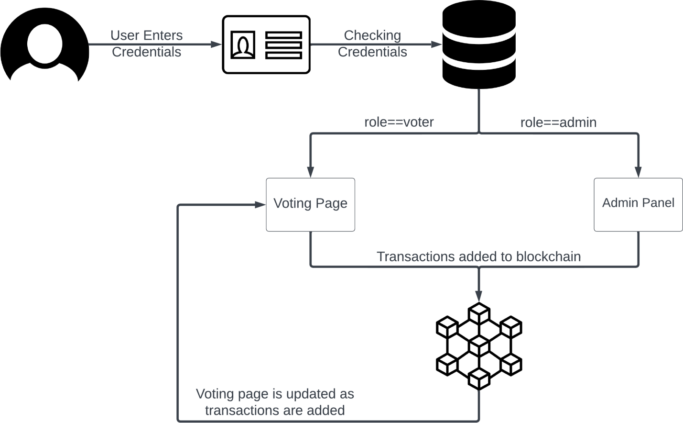Fig. Basic Architecture Diagram

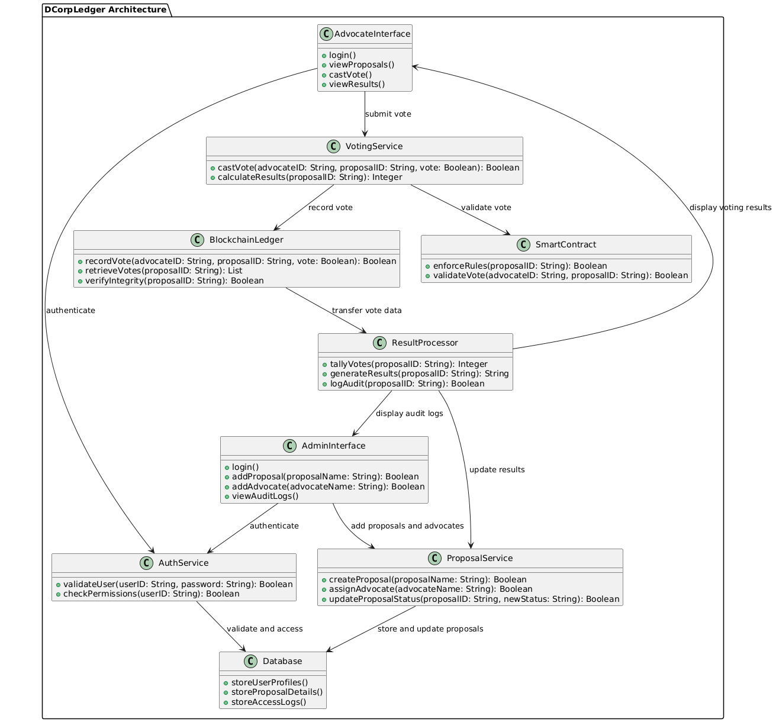

Fig. Architecture Diagram

3. Blockchain Ledger:

* The Blockchain Ledger component securely records all voting transactions on a blockchain to ensure transparency and immutability.
* Each vote is encrypted before being stored on the blockchain, protecting user privacy and ensuring that vote data cannot be tampered with.
* The ledger also verifies the integrity of each vote using blockchain protocols, ensuring that the data remains secure, consistent, and tamper-proof.

4. Smart Contract:

* This component implements smart contracts that enforce voting rules, such as verifying advocate permissions and proposal status before a vote is allowed.
* It checks that each advocate has the right to vote on a specific proposal and that the proposal is open for voting.
* By validating conditions for each vote, the smart contract component ensures compliance with corporate governance policies, providing a rule-based, automated approach to voting.

5. Result Processing:

* Result Processing is responsible for aggregating votes, calculating final results, and ensuring accuracy in vote counting.
* It generates reports displaying the final voting outcomes for each proposal and updates the proposal status accordingly.
* It maintains an audit trail, logging each vote and processing result for accountability, which allows for retrospective examination of voting data if needed.

6. Voting Interface:

* The Voting Interface presents advocates with a user-friendly interface to view active proposals and cast their votes.
* Advocates can review details about each proposal before voting and are guided through a secure submission process to confirm their vote.
* The interface ensures a seamless user experience, enhancing usability while maintaining security, and provides feedback to advocates on successful vote submission.

7. Admin Component:

* User and Proposal Management: Admin has access to functionalities for adding new advocates, creating new proposals, and managing advocate and proposal details on the platform.
* Audit and Monitoring: Admin maintains oversight by viewing audit logs and accessing data related to voting activities for transparency and security.
* Platform Oversight: Admin can perform high-level management tasks, ensuring the system runs smoothly by managing access and monitoring data integrity.

**3.3.2 Data Flow Diagram:**

1. External Entities:

* Advocates (Corporate Users): Represents corporate individuals who participate in the voting process, casting votes on proposals and viewing results.
* Proposals (Corporate Motions): Represents proposals or motions that advocates vote on within the decentralized corporate voting system.
* Blockchain Ledger: The external component that securely records and stores votes, ensuring data integrity and immutability through blockchain technology.
* Smart Contracts: An external system responsible for enforcing the rules of voting, ensuring that only authorized advocates can vote and that the vote complies with defined conditions.
* Result Display: Represents the system that generates and displays voting results to the advocates after the vote tallying is completed.
* Admin: The Admin manages the system, creating proposals, adding advocates, and ensuring the smooth operation of the system. The Admin also audits and monitors the entire process.

2. Processes:

* User Authentication: Verifies the advocate's identity, ensuring that only authorized corporate users can participate in the voting process.
* Vote Casting: Facilitates the process where an advocate casts their vote on a proposal (for or against), ensuring a secure and valid submission.
* Vote Recording and Validation: Records the vote in the Blockchain Ledger and triggers Smart Contracts to validate the vote’s authenticity and compliance with the rules.
* Vote Tallying: The Blockchain Ledger tallies the votes and provides real-time vote data for each proposal.
* Proposal Management: Admin manages the process for creating, updating, and tracking proposals, such as setting their status (open for voting, closed, etc.) and monitoring vote counts.
* Result Generation: The Result Processor component aggregates votes, generates the final results, and ensures that an audit trail is logged for transparency.
* Smart Contract Validation: Validates the conditions of the proposal and checks if advocates are eligible to vote, ensuring that only valid votes are counted.
* Audit and Logging: Ensures all actions in the voting process are logged for transparency, allowing for audits and verification of the system’s integrity.
* Admin Role: The Admin oversees proposal creation, advocate management, auditing, and ensuring system integrity by monitoring logs.

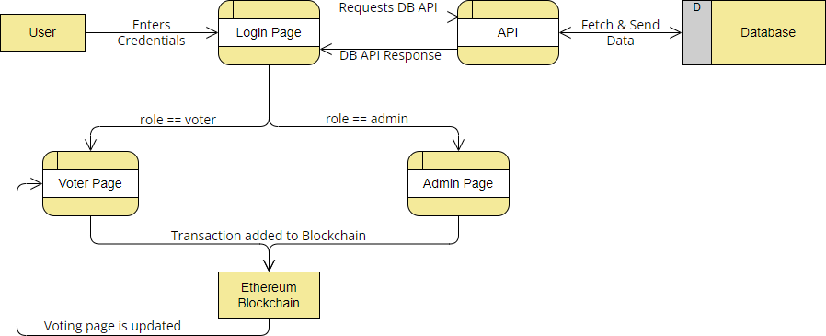Fig. Basic Data Flow Diagram

3. Data Flows:

* Advocate Login Information: Flows from the advocates to the User Authentication process to verify credentials and allow access to the platform.
* Votes (For/Against): Flow from advocates to the Vote Casting process and then to the Blockchain Ledger for recording and validation.
* Proposal Information: Flow between the Proposal Management process and the advocates, allowing them to view and participate in the voting process.
* Vote Results: Flow from the Blockchain Ledger to the Result Processor for tallying and generating the final voting results.
* Audit Data: Flow from the Blockchain Ledger to the Audit and Logging process, ensuring that every vote and action is logged for transparency.
* Admin Actions: Flow from the Admin to the Proposal Management process, adding or updating proposals and adding new advocates.

4. Relationships:

* Advocates interact with various processes: They log in through the authentication process, cast votes on proposals, and view results generated by the system.
* Proposals are created, managed, and voted on: Advocates interact with the Proposal Management process to view and vote on proposals, and the results are processed after the votes are cast.
* The Blockchain Ledger plays a central role: It stores and verifies votes, ensuring the integrity of the voting process, and works with Smart Contracts to validate votes.
* Smart Contracts ensure compliance: They validate each vote, ensuring only eligible advocates can vote and that the process follows the established rules. Result Processor aggregates and displays final results: After the voting is complete, the Result Processor tallies the votes and generates the results that are displayed to the advocates.
* Admin manages the system: Admin can create proposals, manage advocates, and monitor vote integrity through the Proposal Management process and auditing.

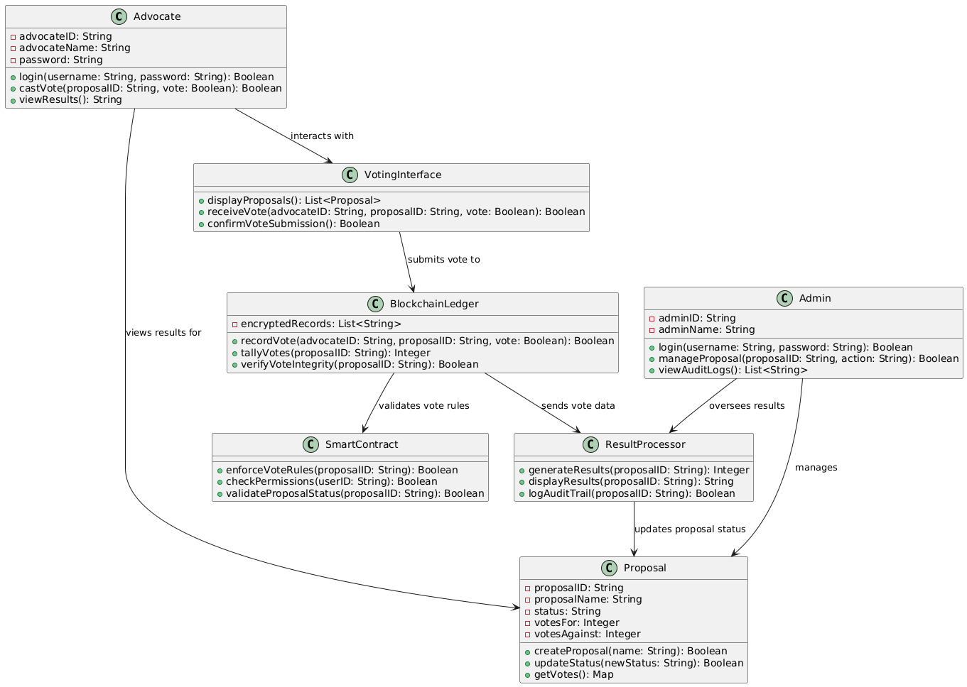

Fig. Data Flow Diagram

5. Purpose:

* The DFD illustrates how the DCorpLedger system facilitates corporate voting, from authentication through to vote casting, tallying, and result generation.
* It highlights the integration of blockchain for data integrity, smart contracts for rule enforcement, and the transparent display of results for corporate governance.
* The Admin is a central figure in managing the system’s operation, overseeing the creation and management of proposals, adding advocates, and ensuring transparency and compliance through audits.
* The DFD also shows how external entities (advocates, proposals, and results) interact with the system to ensure a secure, tamper-proof, and auditable voting process.

**3.3.3 Class Diagram:**

1. Advocate Class:

* Represents corporate users who participate in the voting process, cast votes on proposals, and view voting results.
* Methods include login() for authentication, castVote() to vote on proposals, and viewResults() to see the outcome of votes.

2. Proposal Class:

* Represents the corporate proposals or motions that advocates vote on, with attributes like proposalID, proposalName, and status.
* Methods include createProposal() to initiate a new proposal, updateStatus() to modify proposal status, and getVotes() to fetch current vote tallies.

3. BlockchainLedger Class:

* Ensures data integrity and immutability by securely recording votes using blockchain technology.
* Contains methods like recordVote() to log votes, tallyVotes() to count votes for proposals, and verifyVoteIntegrity() to ensure vote authenticity.
* Plays a key role in maintaining a secure and transparent voting process.

4. SmartContract Class:

* Enforces the rules of the voting system, ensuring only eligible advocates can vote.
* Methods like enforceVoteRules() apply voting conditions, checkPermissions() validates eligibility, and validateProposalStatus() ensures the proposal is open for voting.
* Guarantees compliance with established voting conditions and proposal statuses.

5. ResultProcessor Class:

* Aggregates votes, calculates final results, and ensures transparency.
* Methods include generateResults() to tally votes, displayResults() to present the final outcome, and logAuditTrail() to track all voting activities.
* Maintains accountability and transparency in the voting process.

6. VotingInterface Class:

* Represents the user interface for advocates to view and vote on proposals.
* Methods like displayProposals() present available proposals, receiveVote() accepts votes, and confirmVoteSubmission() finalizes vote submissions.
* Ensures a smooth and user-friendly interaction for advocates during the voting process.

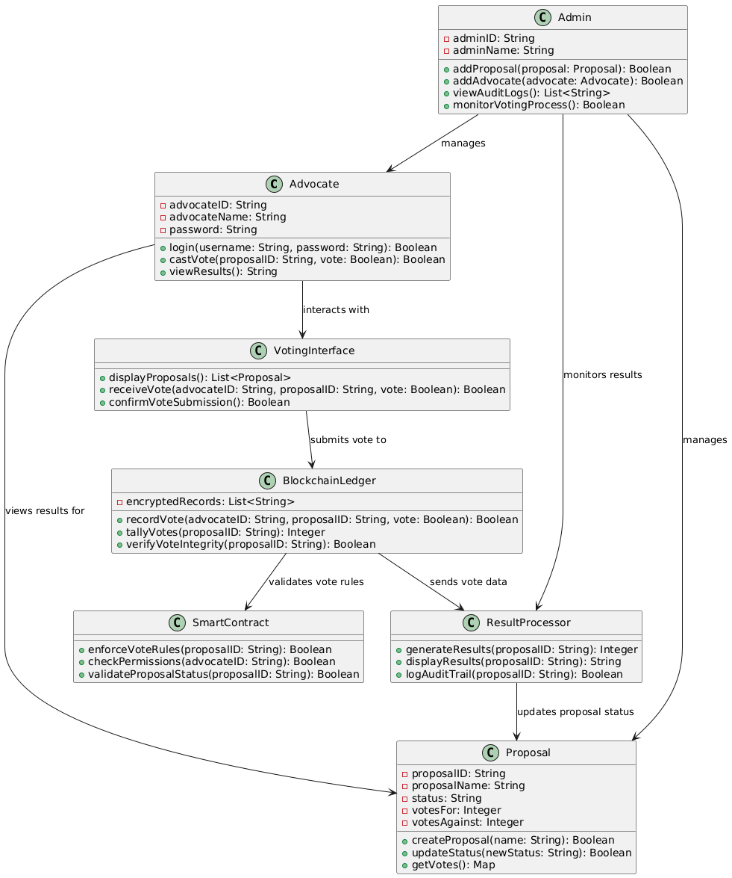

Fig. Class Diagram

7. Admin Class:

* Manages the overall system, including adding proposals and advocates and overseeing the voting process.
* Methods like addProposal() to create proposals, addAdvocate() to register advocates, and viewAuditLogs() to access transparency logs.
* Monitors the voting process through the monitorVotingProcess() method to ensure integrity and proper system operation.

6. Relationships:

* Advocates interact with the VotingInterface to view proposals and cast votes. They also view results through the ResultProcessor.
* Proposals are managed by the Admin, who can create, update, and track them. Advocates participate by casting votes on the proposals.
* The BlockchainLedger securely records votes, ensures integrity, and works with the SmartContract to validate votes and ensure compliance with voting rules.
* SmartContracts enforce the rules and validate the eligibility of advocates and proposals.
* ResultProcessor aggregates and displays final results, also providing audit logs for transparency.
* Admin manages the system, including the creation of proposals, the addition of advocates, and monitoring the voting process for integrity.

**3.3.4 Use Case Diagram:**

1. Login (UC1):

* Description: Allows advocates and administrators to authenticate and access the platform.
* Actors: Advocate, Admin, System
* Preconditions: User must have registered credentials.
* Basic Flow:
  1. Advocate or Admin enters their username and password.
  2. System validates the credentials.
  3. If validation is successful, the user is granted access to the platform.

2. View Proposals (UC2):

* Description: Allows advocates to view all active proposals they can vote on.
* Actors: Advocate, System
* Preconditions: Advocate must be logged in.
* Basic Flow:
  1. Advocate navigates to the proposals section.
  2. System displays a list of active proposals.
  3. Advocate selects a proposal to view more details.

3. Cast Vote (UC3):

* Description: Allows advocates to cast their votes on proposals they are eligible to vote on.
* Actors: Advocate, System
* Preconditions: Advocate must be logged in and have access to a valid proposal.
* Basic Flow:
  1. Advocate views the selected proposal.
  2. Advocate casts a vote for or against the proposal.
  3. System records the vote securely in the BlockchainLedger.

4. View Results (UC4):

* Description: Allows advocates to view the current results of proposals they have voted on.
* Actors: Advocate, System
* Preconditions: Advocate must be logged in.
* Basic Flow:
  1. Advocate navigates to the results section.
  2. System displays the current vote tally for active proposals.
  3. Advocate views the results in real-time.

5. Create Proposal (UC5):

* Description: Allows administrators to create new proposals for voting within the platform.
* Actors: Admin, System
* Preconditions: Admin must be logged in.
* Basic Flow:
  1. Admin selects the option to create a new proposal.
  2. Admin enters the proposal details (name, description, etc.).
  3. System stores the proposal and sets its status to "Open" for voting.

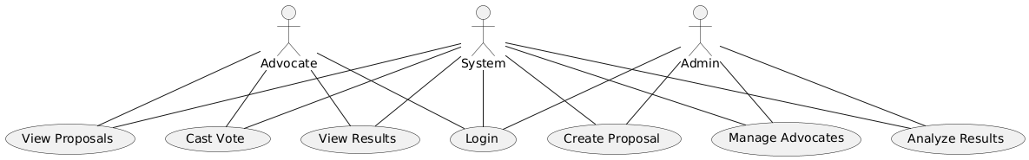

Fig. Use Case Diagram

6. Manage Advocates (UC6):

* Description: Allows administrators to add or remove advocates from the system.
* Actors: Admin, System
* Preconditions: Admin must be logged in.
* Basic Flow:
  1. Admin selects the option to manage advocates.
  2. Admin adds or removes advocates as needed.
  3. System updates the advocate list and notifies affected parties.

7. Analyze Results (UC7):

* Description: Allows administrators to analyze voting results and generate reports based on the data.
* Actors: Admin, System
* Preconditions: Admin must be logged in.
* Basic Flow:
  1. Admin selects the option to analyze results.
  2. Admin selects the proposal(s) they wish to analyze.
  3. System generates an analysis of the voting data, presenting trends, patterns.

**3.3.5 Sequence Diagram:**

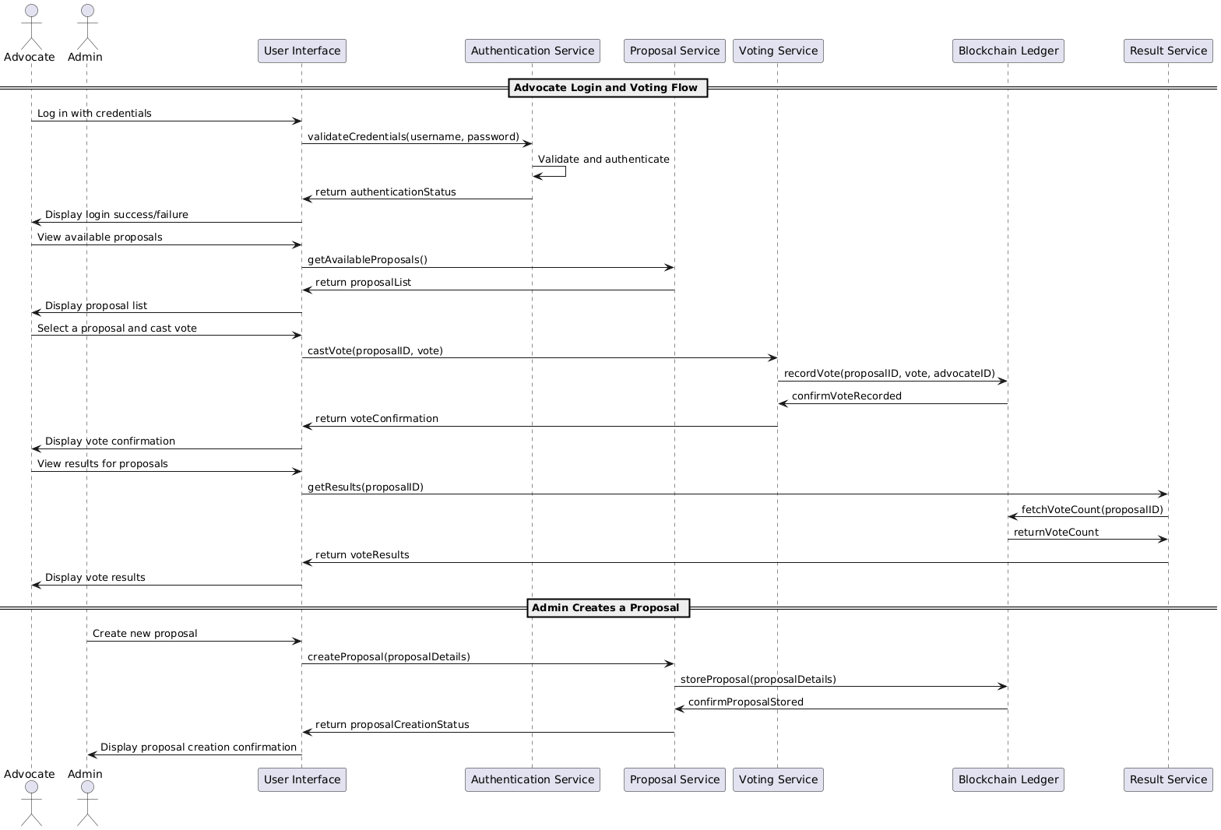

Fig. Sequence Diagram

**In this sequence diagram:**

1. **Advocate logs in to DCorpLedger.**

* Advocate submits credentials through the User Interface.
* Authentication Service validates credentials and confirms login.

2. **Advocate views available proposals.**

* Advocate requests proposal list.
* Proposal Service retrieves and displays available proposals.

3. **Advocate casts a vote on a proposal.**

* Advocate submits vote through User Interface.
* Voting Service records vote in Blockchain Ledger for secure storage.
* Blockchain Ledger confirms vote recording, and Advocate is notified of successful vote submission.

4. **Advocate views voting results.**

* Advocate requests proposal results.
* Result Service retrieves and displays vote count from Blockchain Ledger.

5. **Admin creates a new proposal.**

* Admin submits new proposal details.
* Proposal Service stores proposal in Blockchain Ledger.
* Blockchain Ledger confirms storage, and Admin is notified of successful proposal creation.

**3.3.6 Activity Diagram:**

1. Login Process:

* The activity begins with the Advocate logging into the DCorpLedger platform.
* If the login is successful, the Advocate is directed to access the Voting Interface.
* If login fails, the process ends with a notification to the Advocate.

2. Access Voting Interface:

* Once logged in, the Advocate accesses the Voting Interface.
* The Advocate is presented with a list of proposals, and they can choose a proposal to vote on.

3**.** View and Vote on Proposals:

* If proposals are available, the Advocate views the details and selects a proposal to cast their vote.
* After selecting the proposal, the Advocate confirms their vote submission.
* If no proposals are available, the process ends at this step.

4**.** Record Vote on Blockchain:

* Once the vote is submitted, DCorpLedger records the vote in the blockchain through the BlockchainLedger component.
* This ensures the vote is securely stored and contributes to the overall tally.

5**.** Validate and Tally Votes:

* The SmartContract validates the Advocate's eligibility and enforces the voting rules.
* If valid, the vote is tallied by the BlockchainLedger, contributing to the proposal’s vote count.

6**.**  Generate and Display Results:

* The ResultProcessor aggregates the votes and generates the final voting results.
* The results are then displayed to the Advocate once the tally is complete.

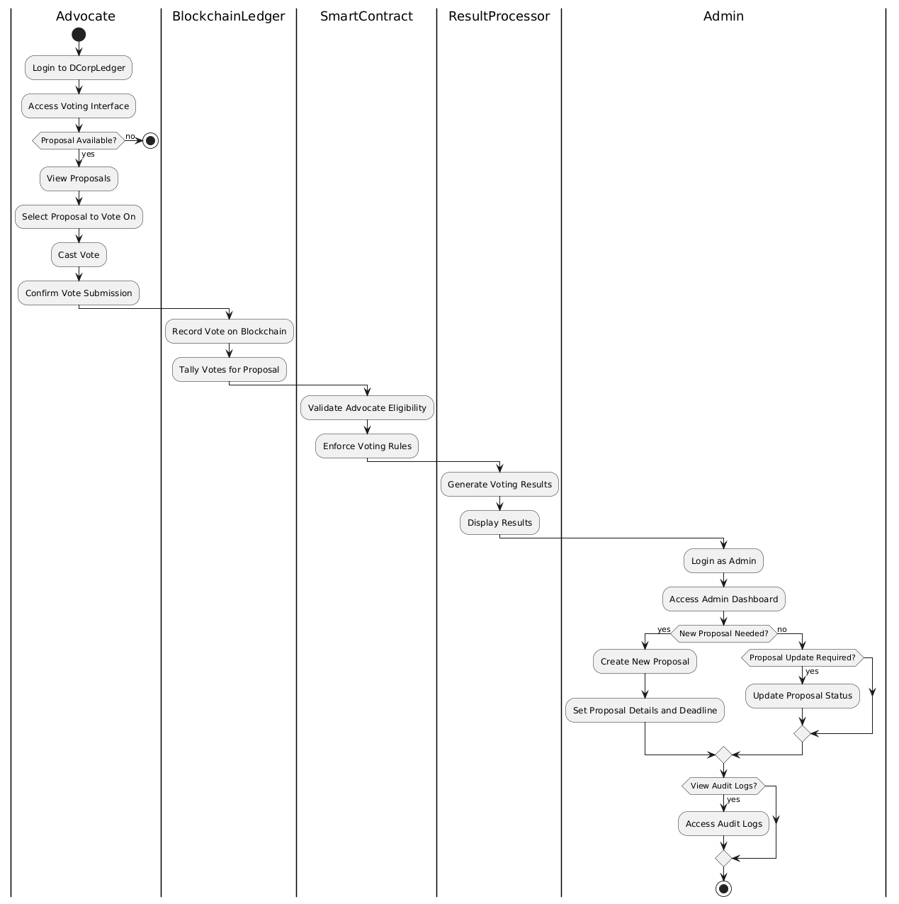

Fig. Activity Diagram

7. Admin Login and Access Dashboard:

* The Admin logs into the DCorpLedger system and navigates to the Admin Dashboard.
* This allows the Admin to perform system management tasks.

8. Create or Update Proposals:

* The Admin can create new proposals, entering proposal details and setting voting deadlines.
* Alternatively, the Admin can update the status of existing proposals to open, close, or modify deadlines as needed.

**4.Implementation & Testing:**

* 1. **Coding Blocks:**
     1. **Migrations.sol:**

pragma solidity ^0.5.15; contract Migrations {

    address public owner;

    uint public last_completed_migration;

    modifier restricted() {

    require(msg.sender == owner, "Access restricted to owner");

    _;

    }

    constructor() public { owner = msg.sender;

    }

    function setCompleted(uint completed) public restricted { last_completed_migration = completed;

    }

    function upgrade(address new_address) public restricted { Migrations upgraded = Migrations(new_address); upgraded.setCompleted(last_completed_migration);

    }

    }

* + 1. **Voting.sol:**

pragma solidity ^0.5.15; contract Voting {

    struct Candidate {

    uint id; string name; string party; uint voteCount;

    }

    mapping (uint => Candidate) public candidates; mapping (address => bool) public voters;

    uint public countCandidates; uint256 public votingEnd; uint256 public votingStart;

    function addCandidate(string memory name, string memory party) public returns(uint) {

    countCandidates ++;

    candidates[countCandidates] = Candidate(countCandidates, name, party, 0);

    return countCandidates;

    }

    function vote(uint candidateID) public { require((votingStart <= now) && (votingEnd > now));

    require(candidateID > 0 && candidateID <= countCandidates);

    //daha önce oy kullanmamıs olmalı require(!voters[msg.sender]);

    voters[msg.sender] = true;

    candidates[candidateID].voteCount ++;

    }

    function checkVote() public view returns(bool){ return voters[msg.sender];

    }

    function getCountCandidates() public view returns(uint) { return countCandidates;

    }

    function getCandidate(uint candidateID) public view returns (uint,string memory, string memory,uint) {

    return (candidateID,candidates[candidateID].name,candidates[candidateID].party, candidates[candidateID].voteCount);

    }

    function setDates(uint256 _startDate, uint256 _endDate) public{ require((votingEnd == 0) && (votingStart == 0) && (_startDate +

    1000000 > now) && (_endDate > _startDate)); votingEnd = _endDate;

    votingStart = _startDate;

    }

    function getDates() public view returns (uint256,uint256) { return (votingStart,votingEnd);

    }

    }

* + 1. **App.js:**

const Web3 = require('web3');

const contract = require('@truffle/contract');

const votingArtifacts = require('../../build/contracts/Voting.json'); var VotingContract = contract(votingArtifacts)

window.App = { eventStart: function() {

window.ethereum.request({ method: 'eth_requestAccounts' }); VotingContract.setProvider(window.ethereum) VotingContract.defaults({from:

window.ethereum.selectedAddress,gas:6654755})

// Load account data

App.account = window.ethereum.selectedAddress;

$("#accountAddress").html("Your Account: " + window.ethereum.selectedAddress);

VotingContract.deployed().then(function(instance){ instance.getCountCandidates().then(function(countCandidates){

$(document).ready(function(){

$('#addCandidate').click(function() {

var nameCandidate = $('#name').val(); var partyCandidate = $('#party').val();

instance.addCandidate(nameCandidate,partyCandidate).the n(function(result){ })

});

$('#addDate').click(function(){ var startDate =

Date.parse(document.getElementById("startDate").value)/1000;

var endDate

= Date.parse(document.getElementById("endDate").value)/1000;

t){

instance.setDates(startDate,endDate).then(function(rsl

console.log("tarihler verildi");

});

});

instance.getDates().then(function(result){

var startDate = new Date(result[0]*1000); var endDate = new Date(result[1]*1000);

$("#dates").text( startDate.toDateString(("#DD#/#MM#/#YYYY#")) + " - " + endDate.toDateString("#DD#/#MM#/#YYYY#"));

}).catch(function(err){ console.error("ERROR! " + err.message)

});

});

for (var i = 0; i < countCandidates; i++ ){ instance.getCandidate(i+1).then(function(data){

var id = data[0]; var name = data[1]; var party = data[2];

var voteCount = data[3];

var viewCandidates = `<tr><td> <input class="form-check- input" type="radio" name="candidate" value="${id}" id=${id}>` + name + "</td><td>" + party + "</td><td>" + voteCount + "</td></tr>"

$("#boxCandidate").append(viewCandidates)

})

}

window.countCandidates = countCandidates

});

instance.checkVote().then(function (voted) { console.log(voted);

if(!voted) {

$("#voteButton").attr("disabled", false);

}

});

}).catch(function(err){ console.error("ERROR! " + err.message)

})

},

vote: function() {

var candidateID = $("input[name='candidate']:checked").val(); if (!candidateID) {

$("#msg").html("<p>Please vote for a candidate.</p>") return

}

VotingContract.deployed().then(function(instance){

instance.vote(parseInt(candidateID)).then(function(result){

$("#voteButton").attr("disabled", true);

$("#msg").html("<p>Voted</p>"); window.location.reload(1);

})

}).catch(function(err){ console.error("ERROR! " + err.message)

})

}

}

window.addEventListener("load", function() { if (typeof web3 !== "undefined") {

console.warn("Using web3 detected from external source like Metamask")

window.eth = new Web3(window.ethereum)

} else {

console.warn("No web3 detected. Falling back to http://localhost:9545. You should remove this fallback when you deploy live, as it's inherently insecure. Consider switching to Metamask for deployment. More info here: http://truffleframework.com/tutorials/truffle-and-metamask")

window.eth = new Web3(new Web3.providers.HttpProvider("http://127.0.0.1:9545"))

}

window.App.eventStart()

})

* + 1. **Login.js:**

const loginForm = document.getElementById('loginForm'); loginForm.addEventListener('submit', (event) => {

    event.preventDefault();

    const voter_id = document.getElementById('voter-id').value; const password = document.getElementById('password').value; const token = voter_id;

    const headers = { 'method': "GET",

    'Authorization': `Bearer ${token}`,

    };

    fetch(`http://127.0.0.1:8000/login?voter_id=${voter_id}&password=${pas sword}`, { headers })

    .then(response => { if (response.ok) {

    return response.json();

    } else {

    throw new Error('Login failed');

    }

    })

    .then(data => {

    if (data.role === 'admin') { console.log(data.role)

    localStorage.setItem('jwtTokenAdmin', data.token); window.location.replace(`http://127.0.0.1:8080/admin.html?Authoriz

    ation=Bearer ${localStorage.getItem('jwtTokenAdmin')}`);

    } else if (data.role === 'user'){ localStorage.setItem('jwtTokenVoter', data.token); window.location.replace(`http://127.0.0.1:8080/index.html?Authoriz

    ation=Bearer ${localStorage.getItem('jwtTokenVoter')}`);

    }

    })

    .catch(error => {

    console.error('Login failed:', error.message);

    });

    });

* + 1. **Main.py:**

# Import required modules import dotenv

import os

import mysql.connector

from fastapi import FastAPI, HTTPException, status, Request from fastapi.middleware.cors import CORSMiddleware

from fastapi.encoders import jsonable_encoder from mysql.connector import errorcode

import jwt

# Loading the environment variables dotenv.load_dotenv()

# Initialize the todoapi app app = FastAPI()

# Define the allowed origins for CORS origins = [

"http://localhost:8080", "http://127.0.0.1:8080",

]

# Add CORS middleware app.add_middleware(

CORSMiddleware, allow_origins=origins, allow_credentials=True, allow_methods=["*"], allow_headers=["*"],

)

# Connect to the MySQL database try:

cnx = mysql.connector.connect( user=os.environ['MYSQL_USER'], password=os.environ['MYSQL_PASSWORD'], host=os.environ['MYSQL_HOST'], database=os.environ['MYSQL_DB'],

)

cursor = cnx.cursor()

except mysql.connector.Error as err:

if err.errno == errorcode.ER_ACCESS_DENIED_ERROR: print("Something is wrong with your user name or password")

elif err.errno == errorcode.ER_BAD_DB_ERROR: print("Database does not exist")

else:

print(err)

# Define the authentication middleware async def authenticate(request: Request):

try:

api_key = request.headers.get('authorization').replace("Bearer

", "")

cursor.execute("SELECT * FROM voters WHERE voter_id = %s",

(api_key,))

if api_key not in [row[0] for row in cursor.fetchall()]: raise HTTPException(

status_code=status.HTTP_401_UNAUTHORIZED, detail="Forbidden"

)

except:

raise HTTPException( status_code=status.HTTP_401_UNAUTHORIZED, detail="Forbidden"

)

# Define the POST endpoint for login @app.get("/login")

async def login(request: Request, voter_id: str, password: str): await authenticate(request)

role = await get_role(voter_id, password)

# Assuming authentication is successful, generate a token

token = jwt.encode({'password': password, 'voter_id': voter_id, 'role': role}, os.environ['SECRET_KEY'], algorithm='HS256')

return {'token': token, 'role': role}

# Replace 'admin' with the actual role based on authentication async def get_role(voter_id, password):

try:

cursor.execute("SELECT role FROM voters WHERE voter_id = %s AND password = %s", (voter_id, password,))

role = cursor.fetchone() if role:

return role[0] else:

raise HTTPException( status_code=status.HTTP_401_UNAUTHORIZED, detail="Invalid voter id or password"

)

except mysql.connector.Error as err: print(err)

raise HTTPException( status_code=status.HTTP_500_INTERNAL_SERVER_ERROR, detail="Database error"

)

* + 1. **Package.json:**

6.  Package.json

{

"name": "decentralized-voting", "version": "1.0.0",

"description": "",

"main": "index.js", "scripts": {

"test": "echo \"Error: no test specified\" && exit 1"

},

"author": "",

"license": "ISC", "dependencies": {

"jsonwebtoken": "^9.0.0", "@truffle/contract": "^4.6.18", "browserify": "^17.0.0",

"dotenv": "^16.0.3",

"express": "^4.18.2",

"web3": "^1.9.0"

}

}

* 1. **Sample Code:**

**4.2.1 Login.html:**

<!DOCTYPE html>

<html lang="en">

<head>

    <meta charset="utf-8">

    <meta http-equiv="X-UA-Compatible" content="IE=edge">

    <meta name="viewport" content="width=device-width, initial-scale=1">

    <title>D-CorpLedger Login Page</title>

    <link rel="stylesheet" type="text/css" href="../css/login.css">

    <link href="https://fonts.googleapis.com/css2?family=Montserrat:wght@400;700&display=swap" rel="stylesheet"> <!-- Changed to Montserrat -->

</head>

<body>

    <div class="header">

        <h1>Decentralized Voting Using Ethereum Blockchain</h1>

    </div>

    <div class="container">

        <h2>Login</h2>

        <form id="loginForm">

            <div class="form-group">

                <label for="voter-id">Voter ID</label>

                <input type="text" class="form-control" id="voter-id" name="voter-id" placeholder="Voter ID">

            </div>

            <div class="form-group">

                <label for="password">Password</label>

                <input type="password" class="form-control" id="password" name="password" placeholder="Password">

            </div>

            <button type="submit" class="btn"><b>Login</b></button>

        </form>

    </div>

    <script src="https://ajax.googleapis.com/ajax/libs/jquery/3.3.1/jquery.min.js"></script>

    <script src="https://cdnjs.cloudflare.com/ajax/libs/popper.js/1.14.0/umd/popper.min.js"></script>

    <script src="../js/login.js" type="module"></script>

</body>

</html>

**4.2.2 Index.html :**

<!DOCTYPE html>

<html lang="en">

<head>

    <meta charset="utf-8">

    <meta http-equiv="X-UA-Compatible" content="IE=edge">

    <meta name="viewport" content="width=device-width, initial-scale=1">

    <title>Admin Portal</title>

    <!-- External Stylesheet -->

    <link rel="stylesheet" type="text/css" href="../css/index.css">

    <!-- Google Fonts -->

    <link href="https://fonts.googleapis.com/css2?family=Montserrat:wght@500;700&display=swap" rel="stylesheet">

    <!-- Bootstrap for Modern Layout -->

    <link rel="stylesheet" href="https://stackpath.bootstrapcdn.com/bootstrap/4.5.2/css/bootstrap.min.css">

</head>

<body>

    <header>

        <h1>D-CorpLedger</h1>

        <h2>(Corporate Voting Reimagined using Decentralization)</h2>

        <h3>Voting Dates: <span id="dates"></span></h3>

    </header>

    <div class="container">

        <legend>Vote</legend>

        <table class="table text-center">

            <thead>

                <tr>

                    <th>Proposal Name</th>

                    <th>Advocate Name</th>

                    <th>Total Votes</th>

                </tr>

            </thead>

            <tbody id="boxCandidate"></tbody>

        </table>

        <div id="vote">

            <p>Please select one of the candidates and click the button below to advocate.</p>

            <button id="voteButton" class="btn" onclick="App.vote()" disabled>Advocate</button>

            <div id="msg"></div>

            <div id="vote-box"></div>

        </div>

    </div>

    <div id="account">

        <p id="accountAddress"></p>

    </div>

    <footer>

        <p>&copy; 2024 Voting System | All Rights Reserved</p>

    </footer>

    <script src="https://ajax.googleapis.com/ajax/libs/jquery/3.3.1/jquery.min.js"></script>

    <script src="https://cdnjs.cloudflare.com/ajax/libs/popper.js/1.14.0/umd/popper.min.js"></script>

    <script src="../dist/app.bundle.js" type="module"></script>

</body>

</html>

**4.2.3 Admin.html :**

<!DOCTYPE html>

<html lang="en">

<head>

    <meta charset="utf-8">

    <meta http-equiv="X-UA-Compatible" content="IE=edge">

    <meta name="viewport" content="width=device-width, initial-scale=1">

    <title>Admin Portal</title>

    <!-- External Stylesheet -->

    <link rel="stylesheet" type="text/css" href="../css/admin.css">

    <!-- Google Fonts -->

    <link href="https://fonts.googleapis.com/css2?family=Montserrat:wght@500;700&display=swap" rel="stylesheet">

    <!-- Bootstrap for Modern Layout -->

    <link rel="stylesheet" href="https://stackpath.bootstrapcdn.com/bootstrap/4.5.2/css/bootstrap.min.css">

</head>

<body>

    <header class="text-center">

        <div class="container">

            <h2>D-CorpLedger</h2> <!-- D-CorpLedger Title -->

            <h1>Decentralized Voting Using Ethereum Blockchain</h1>

            <p>Admin Portal</p>

        </div>

    </header>

    <div class="container">

        <legend>Add Proposal</legend>

        <table class="table text-center">

            <tr>

                <th><span class="input-label">Proposal Name</span></th>

                <td><input id="proposalName" type="text" name="proposalName" placeholder="Enter proposal name" autocomplete="off"></td>

                <th><span class="input-label">Advocate</span></th>

                <td><input id="advocate" type="text" name="advocate" placeholder="Enter advocate name"></td>

            </tr>

        </table>

        <input id="addProposal" type="submit" name="submit" value="Add Proposal">

        <p id="msg"></p>

    </div>

    <div class="container">

        <legend>Define Voting Dates</legend>

        <table class="table text-center">

            <tr>

                <th><span class="input-label">Start Date</span></th>

                <td><input id="startDate" type="date" name=""></td>

                <th><span class="input-label">End Date</span></th>

                <td><input id="endDate" type="date" name=""></td>

            </tr>

        </table>

        <input id="addDate" type="submit" name="submit" value="Define Dates">

        <p id="msg"></p>

    </div>

    <!-- External JS Libraries -->

    <script src="https://ajax.googleapis.com/ajax/libs/jquery/3.3.1/jquery.min.js"></script>

    <script src="https://cdnjs.cloudflare.com/ajax/libs/popper.js/1.14.0/umd/popper.min.js"></script>

    <script src="../dist/app.bundle.js" type="module"></script>

</body>

</html>

* 1. **Execution Flow:**

**4.3.1 Advocate Interaction:**

* The Advocate navigates to the D-CorpLedger platform.
* They are presented with options to either log in or register if they don't have an account.

**4.3.2 Login/Sign Up:**

• If the Advocate is new, they choose the sign-up option, providing necessary details like Advocate ID and password.

• If the Advocate already has an account, they log in using their credentials.

**4.3.3 Accessing the Platform:**

* Upon successful login, the Advocate is directed to the main dashboard of D-CorpLedger.
  + 1. **Exploring Features:**

The Advocate can explore various features of D-CorpLedger, including:

* + Viewing a list of active Proposals: They can view details of each Proposal and read about the Advocates who submitted them.
  + Casting a Vote: Advocates can cast votes on active Proposals within defined voting periods.
    1. **Voting Process:**

The Advocate engages with the voting platform by:

* + Selecting an active Proposal to support or oppose.
  + Casting their vote securely, with the system recording the vote as part of the blockchain.
  + Receiving confirmation once the vote is successfully recorded.

**4.3.6 Advocate Logout:**

* When the Advocate has completed their tasks, they can securely log out of D-CorpLedger to end their session.

**4.4 Testing :**

**4.4.1** **No Proper Credentials Testing:**

|  |  |
| --- | --- |
| **Test Case No.** | 1 |
| **Test Type** | Unit Test |
| **Name of Test** | Checking JWT Authorization |
| **Test Case Description** | The objective of this test case is to check jwt authorization. |
| **Input** | Login and Password |
| **Expected Output** | Advocate should not be able to login without proper authorization. |
| **Actual Output** | Advocate cannot access voting or admin page without authorization. |
| **Result** | Pass |
| **Comments** | Working properly. |

**4.4.2** **Proper Credentials Testing:**

|  |  |
| --- | --- |
| **Test Case No.** | 2 |
| **Test Type** | Functional Test |
| **Name of Test** | Verify Advocate login |
| **Test Case Description** | The objective of this test case is to verify that Advocate can login to the voting portal. |
| **Input** | Voter_id and password |
| **Expected Output** | Advocate must be able to login if credentials match the database, else unauthorized error is shown. |
| **Actual Output** | Advocate is able to login with correct credentials only. |
| **Result** | Pass |
| **Comments** | Working properly. |

**4.4.3** **Proposal Registration Checking:**

|  |  |
| --- | --- |
| **Test Case No.** | 3 |
| **Test Type** | Unit Test |
| **Name of Test** | Verify Proposal registration |
| **Test Case Description** | The objective of this test case is to verify that Proposal can be registered by admin. |
| **Input** | Proposal name and party. |
| **Expected Output** | Registration transaction should be successful. |
| **Actual Output** | Registration transaction is successful. |
| **Result** | Pass |
| **Comments** | Working properly. |

**4.4.4** **Date Generation:**

|  |  |
| --- | --- |
| **Test Case No.** | 4 |
| **Test Type** | Unit Test |
| **Name of Test** | Verify date registration |
| **Test Case Description** | The objective of this test case is to verify that date of voting can be specified by admin. |
| **Input** | Starting and ending date |
| **Expected Output** | Date transaction should be successful. |
| **Actual Output** | Date transaction is successful. |
| **Result** | Pass |
| **Comments** | Working properly. |

**4.4.5 Vote Transaction:**

|  |  |
| --- | --- |
| **Test Case No.** | 5 |
| **Test Type** | Functional Test |
| **Name of Test** | Verify voting |
| **Test Case Description** | The objective of this test case is to verify that Advocate is able to cast their vote. |
| **Input** | Select a Proposal and click “Vote” button. |
| **Expected Output** | Vote transaction should be successful. |
| **Actual Output** | Vote transaction is successful. |
| **Result** | Pass |
| **Comments** | Working properly. |

**5. Results:**

**5.1 Resulting Screens:**

**5.1.1 Login Page:**

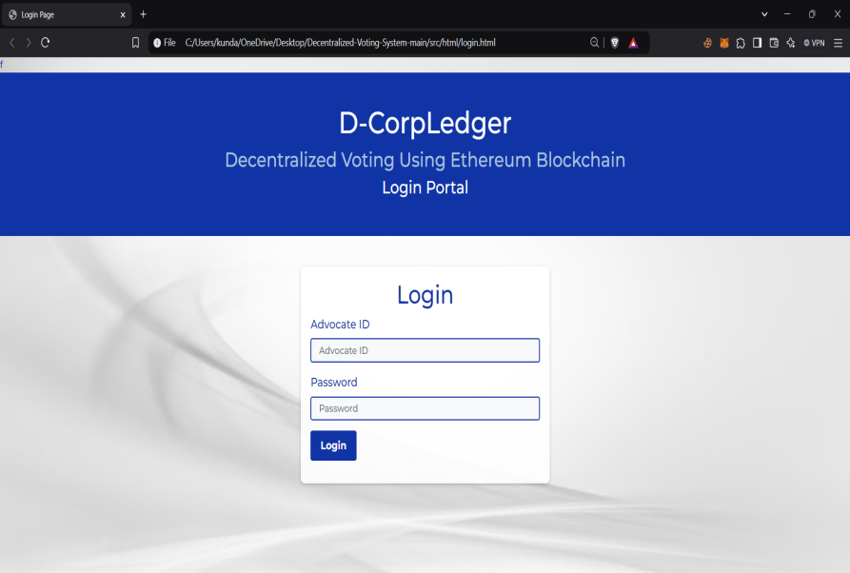

**5.1.2 Index Page :**

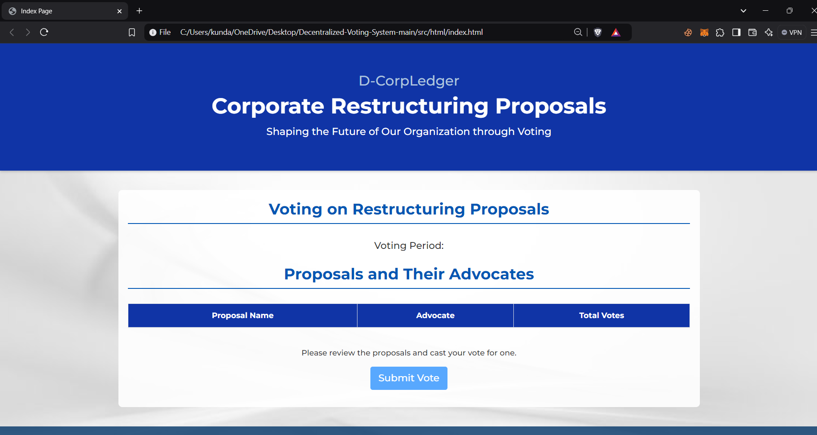

**5.1.3**  **Admin Page:**



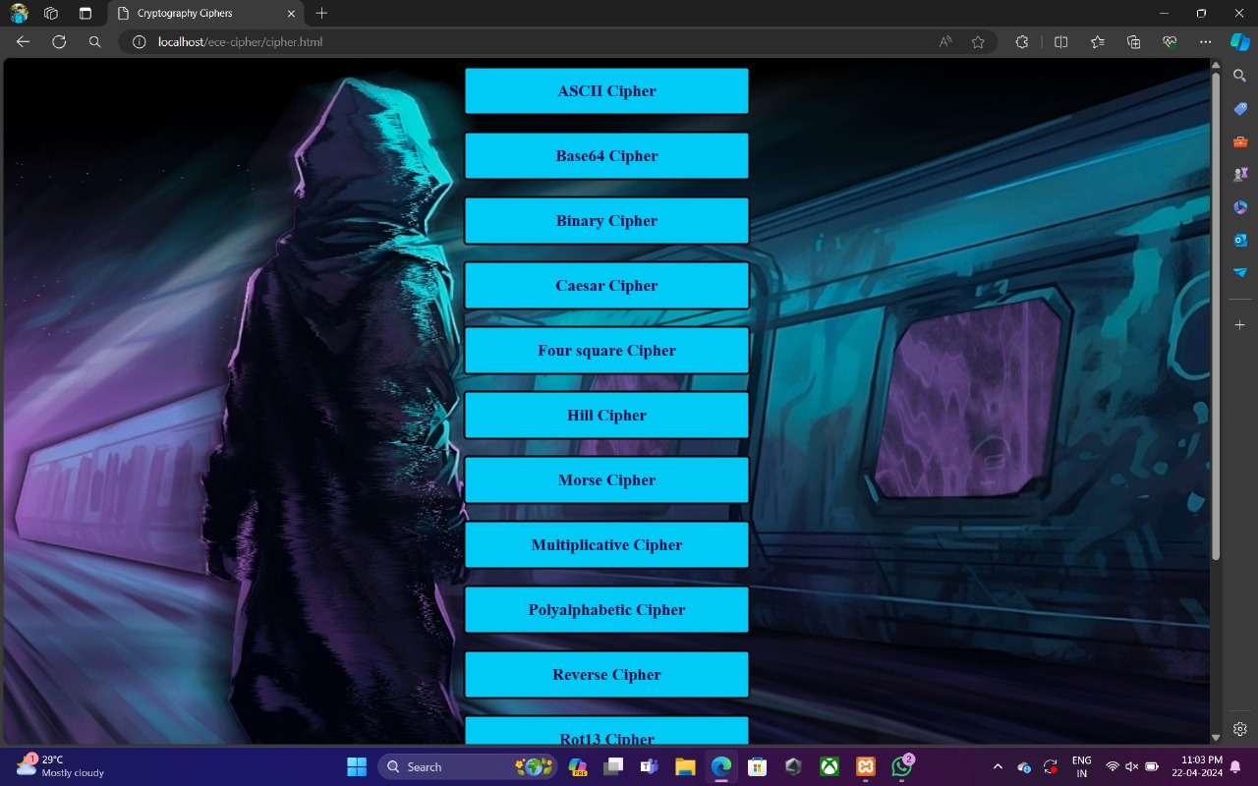**5.1.4 Local Hosting Log:**

**5.1.5 D-CorpLedger Hosting Logs:**

**5.1.6 Advocate and Admin Database:**

**6. Conclusions & Future Scope:**

**6.1 Conclusion:**

The implementation of D-CorpLedger has resulted in transformative outcomes in the realm of corporate governance and shareholder voting. An analysis of user engagement and voting participation metrics reveals a substantial increase in voter turnout, with shareholders actively utilizing the platform to cast their votes securely and transparently. The elimination of traditional intermediaries has streamlined the voting process, significantly reducing the time and costs associated with corporate decision-making.

Moreover, the integration of advanced smart contracts has automated key functions such as vote verification and result dissemination, ensuring accuracy and mitigating the risk of human error. Feedback from users indicates a heightened sense of trust and satisfaction with the voting process, underscoring the platform's effectiveness in enhancing the integrity of corporate governance.

Partnerships established with corporate entities, regulatory bodies, and blockchain advocacy groups have further bolstered D-CorpLedger’s credibility and operational reach.

**6.2 Future Scope:**

* Scalability to Larger Corporations: As blockchain technology matures, D-CorpLedger can be scaled to accommodate larger organizations with a vast number of shareholders. The platform can handle increasing volumes of votes and proposals without compromising performance or security.
* Integration with Global Voting Systems: D-CorpLedger can be extended to support global corporations, enabling shareholders from different geographical locations to participate in voting processes seamlessly.
* AI-Driven Decision Insights: Artificial intelligence (AI) could be integrated into the system to analyse voting patterns and provide insights for corporate decision-makers. This could help predict outcomes and provide recommendations for improving governance.
* Enhanced Security Features: As blockchain technology evolves, D-CorpLedger can integrate advanced security protocols, such as quantum-resistant cryptography, to further enhance the protection of votes and voter data against emerging cybersecurity threats.

**7. Bibliography:**

**7.1 References:**

[1] Nakamoto, S. (2008). Bitcoin: A peer-to-peer electronic cash system. Bitcoin.org, 1-9.

[2] Buterin, V. (2014). A next-generation smart contract and decentralized application platform. Ethereum White Paper, 1-36.

[3] Wood, G. (2014). Ethereum: A secure decentralized generalized transaction ledger. Ethereum Yellow Paper, 1-32.

[4] Christidis, K., & Devetsikiotis, M. (2016). Blockchains and smart contracts for the Internet of Things. IEEE Access, 4, 2292-2303.

[5] Gupta, M., & Gupta, S. (2020). Security and privacy in blockchain-based decentralized voting. Future Generation Computer Systems, 112, 209-222.

[6] Swan, M. (2015). Blockchain: Blueprint for a new economy. O'Reilly Media.

[7] Zhang, R., Xue, R., & Liu, L. (2019). Security and privacy on blockchain. ACM Computing Surveys, 52(3), Article 55.

[8] Nguyen, Q. K. (2016). Blockchain - a financial technology for future sustainable development. In Proceedings of the 3rd International Conference on Green Technology and Sustainable Development, 51-54.

[9] Pilkington, M. (2016). Blockchain technology: Principles and applications. In Research Handbook on Digital Transformations (pp. 225-253). Edward Elgar Publishing.

[10] Tschorsch, F., & Scheuermann, B. (2016). Bitcoin and beyond: A technical survey on decentralized digital currencies. IEEE Communications Surveys & Tutorials, 18(3), 2084-2123.

[11] Zyskind, G., Nathan, O., & Pentland, A. (2015). Decentralizing privacy: Using blockchain to protect personal data. In Proceedings of the IEEE Security and Privacy Workshops, 180-184.

[12] Yaga, D., Mell, P., Roby, N., & Scarfone, K. (2018). Blockchain technology overview. National Institute of Standards and Technology (NIST), U.S. Department of Commerce, Special Publication 800-300.

[13] Gatteschi, V., Lamberti, F., Demartini, C., Pranteda, C., & Santamaría, V. (2018). Blockchain and smart contracts for insurance: Is the technology mature enough? Future Internet, 10(2), Article 20.

[14] Eyal, I., & Sirer, E. G. (2014). Majority is not enough: Bitcoin mining is vulnerable. Communications of the ACM, 61(7), 95-102.

[15] Tapscott, D., & Tapscott, A. (2016). Blockchain revolution: How the technology behind Bitcoin is changing money, business, and the world. Penguin.

**7.2 Papers:**

• Gupta, M., & Gupta, S. (2020). Security and Privacy in Blockchain-based Decentralized Voting. Future Generation Computer Systems, 112, 209-222.

• Allen, D., & Berg, C. (2020). Blockchain Governance: Distributed Ledgers, Non-market Decision Making, and the Legitimacy of the State. Journal of the British Blockchain Association, 3(2), 1-20.

• Christidis, K., & Devetsikiotis, M. (2016). Blockchains and Smart Contracts for the Internet of Things. IEEE Access, 4, 2292-2303.

• Zyskind, G., Nathan, O., & Pentland, A. (2015). Decentralizing Privacy: Using Blockchain to Protect Personal Data. Proceedings of the IEEE Security and Privacy Workshops, 180-184.

• Li, X., Jiang, P., Chen, T., Luo, X., & Wen, Q. (2017). A Survey on the Security of Blockchain Systems. Future Generation Computer Systems, 107, 841-853.

• Zhang, R., Xue, R., & Liu, L. (2019). Security and Privacy on Blockchain. ACM Computing Surveys, 52(3), Article 55.

• Yaga, D., Mell, P., Roby, N., & Scarfone, K. (2018). Blockchain Technology Overview. National Institute of Standards and Technology (NIST), U.S. Department of Commerce, Special Publication 800-300.

• Eyal, I., & Sirer, E. G. (2014). Majority is Not Enough: Bitcoin Mining is Vulnerable. Communications of the ACM, 61(7), 95-102.

• Gatteschi, V., Lamberti, F., Demartini, C., Pranteda, C., & Santamaría, V. (2018). Blockchain and Smart Contracts for Insurance: Is the Technology Mature Enough? Future Internet, 10(2), Article 20.

• Xu, X., et al. (2017). A Taxonomy of Blockchain-based Systems for Architecture Design. Proceedings of the IEEE International Conference on Software Architecture, 243-252.

**8. Web Link of Project:**

Github: <https://github.com/TheNeerajKundarapu/D-Corp-Ledger.git>

Document Report:

**9. Paper Publication:**

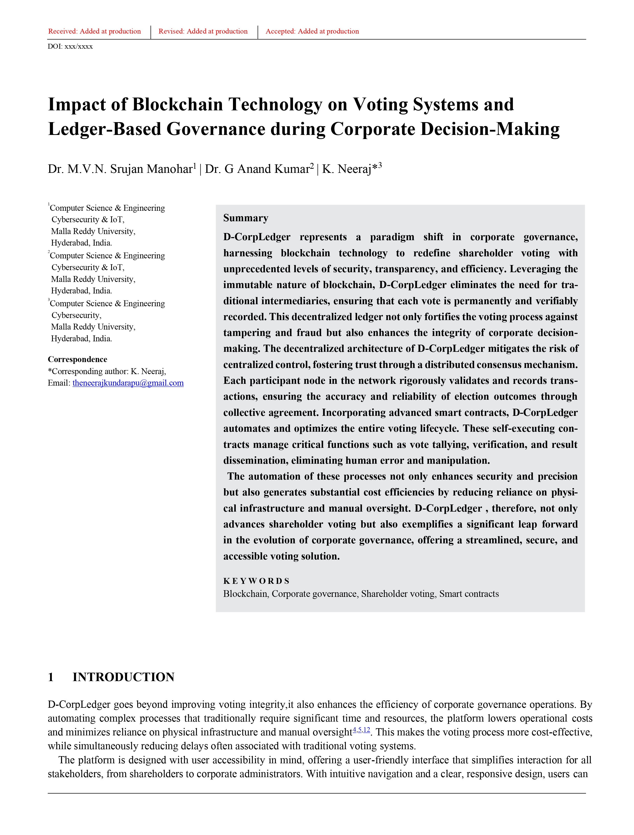

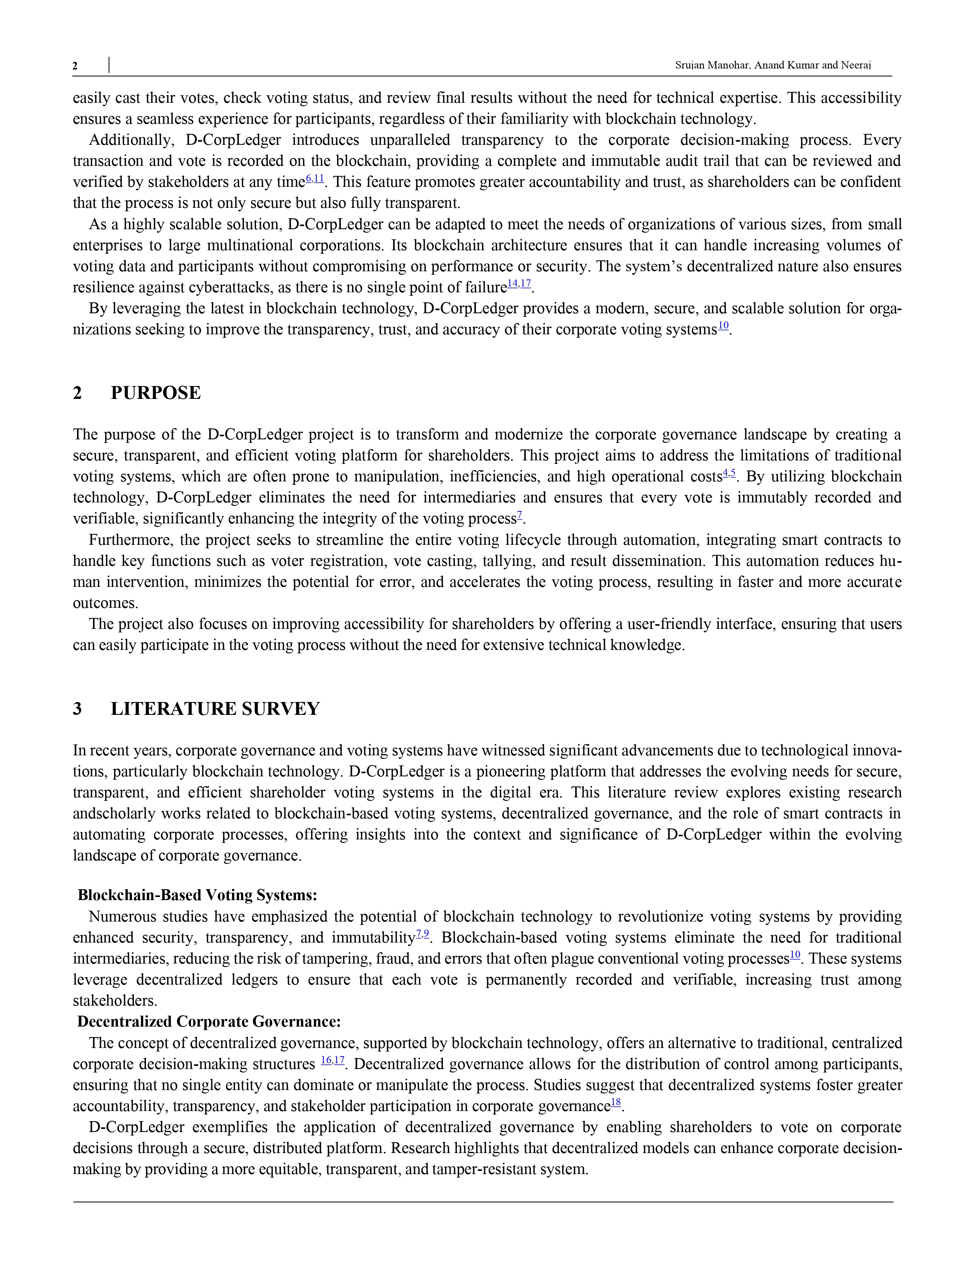

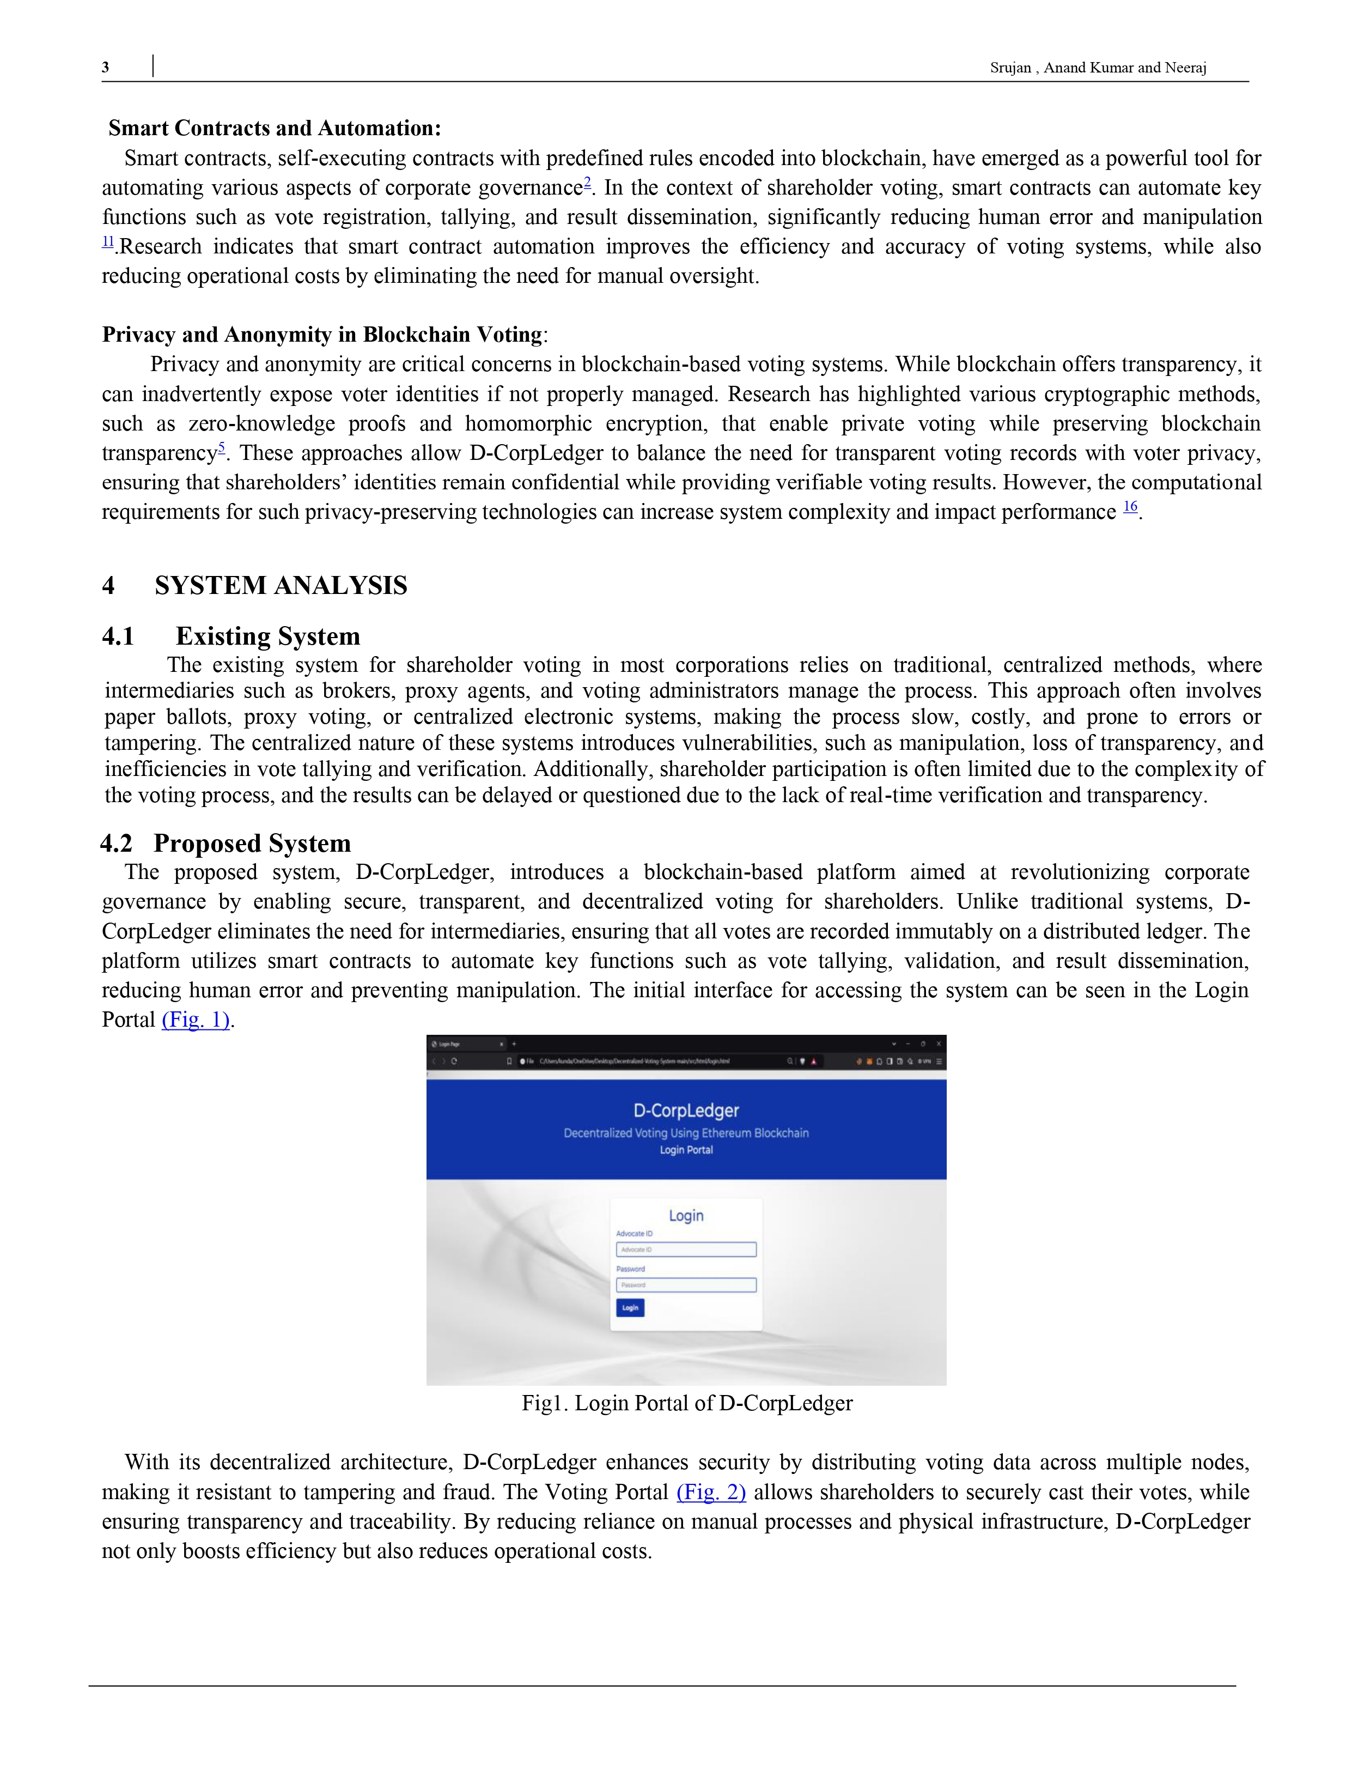

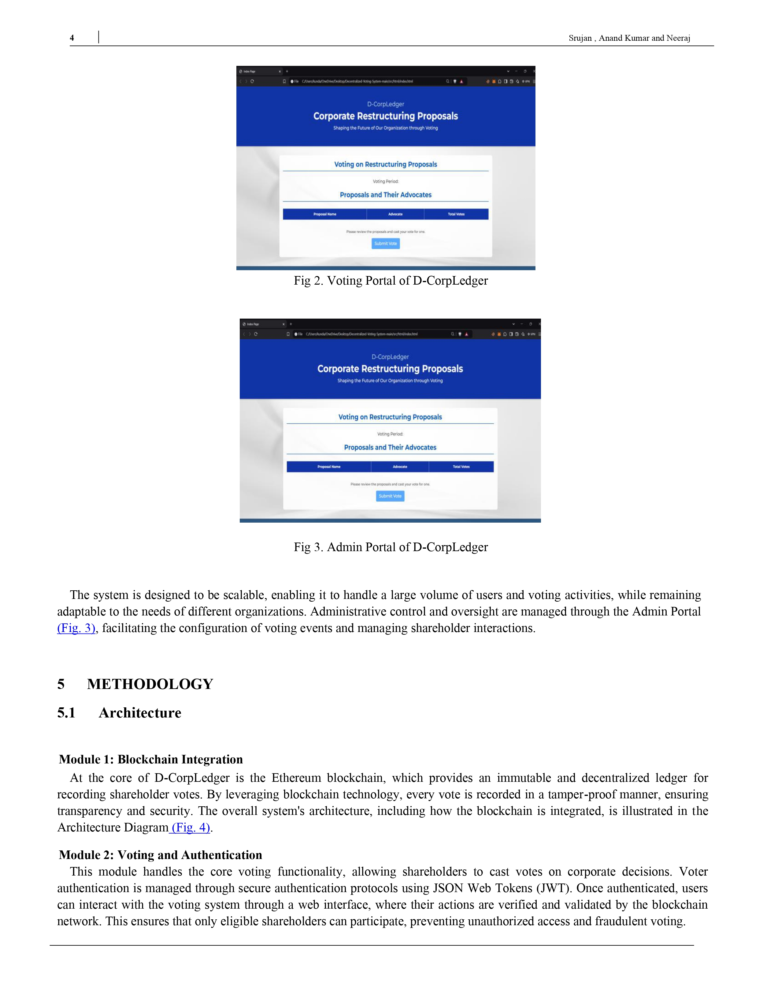

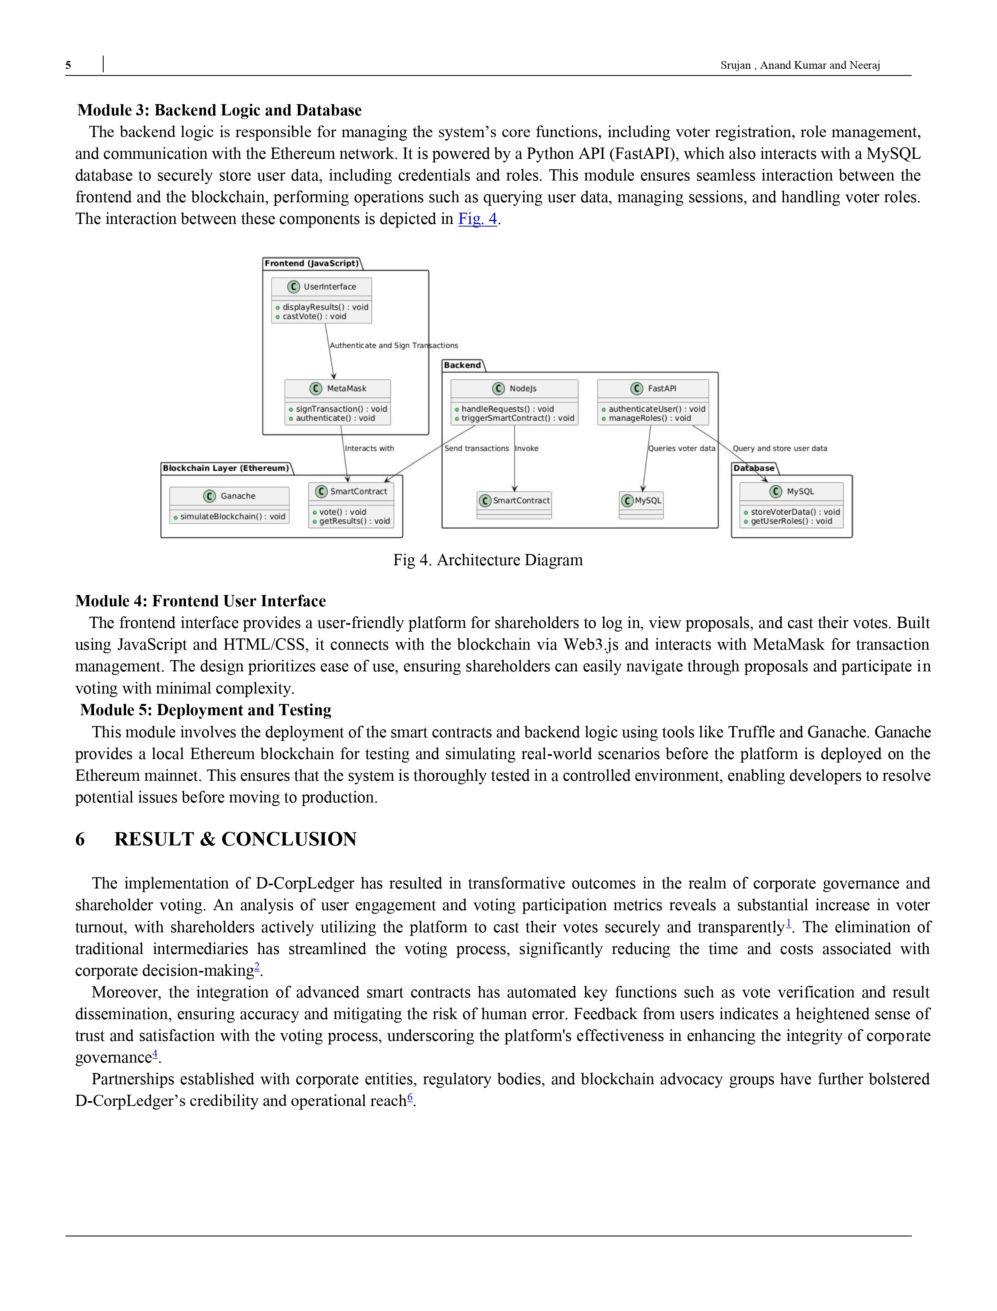

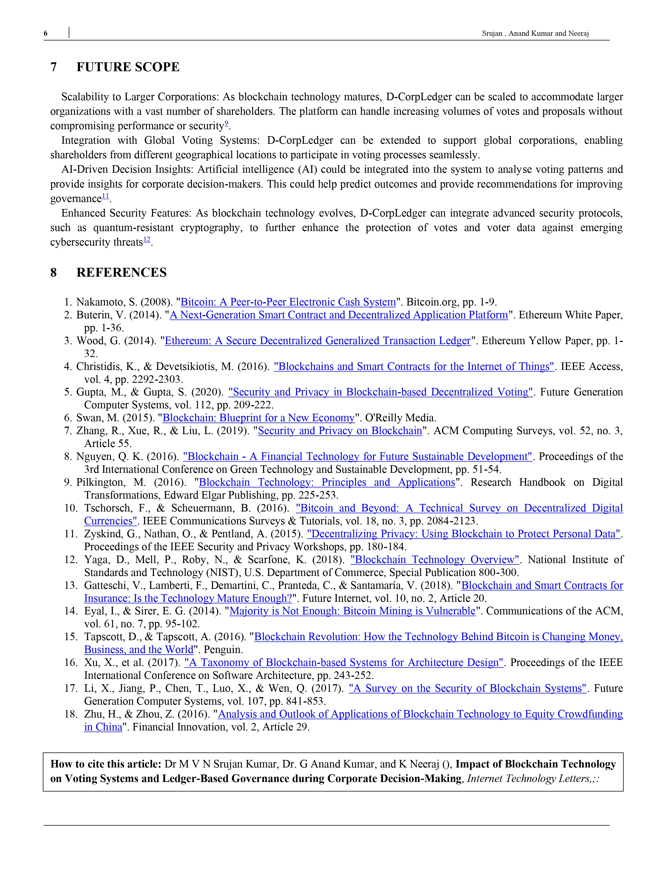

**10. Poster Presentation:**

